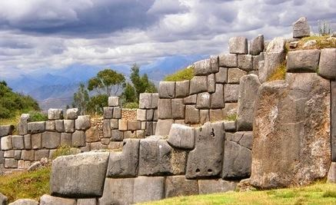
Aztec, Maya, and Incan WebQuest

Goals of the Webquest
During this webquest, you will complete the following tasks:

_____1. On the map provided, you will identify where the Incan, Maya, and Aztec empires were located.
_____2. You will also answer the questions pertaining to the religion, science and culture of each civilization. (extra Credit)
_____3. You will answer the following question in paragraph form:
a. Which of the 3 civilizations would you have wanted to live in? Give at least two reasons why.

Begin your webquest by using the links below to answer the questions and complete the tasks.

Begin your webquest here...

- Geography: On the map provided…
  - Identify where the Incan, Mayan, and Aztec civilizations were located. Label them on the map!

    - http://www.classzone.com/net_explorations/U4/U4_article1.cfm

- Religions:
  - Were these empires polytheistic or monotheistic?
    - Name at least TWO gods from each civilization. What they were the god of?
http://mayaincaaztec.com/religion.html
o
      - Aztec-

      - Maya-

      - Inca-

    - Explain the leadership of their religions (Who is the head of their religion, how are they selected, etc.)

Aztecs
http://www.historyworld.net/wrldhis/plaintexthistories.asp?historyid=aa12
- What was the name of the Aztec capital/main city?
- Who was the Aztec’s main god that they worshipped? What were their sun rituals?
- Who conquered the Aztecs? How was he eventually able to defeat the Aztecs?

http://knowledgenuts.com/2013/10/22/the-difference-between-the-aztec-maya-inca-and-olmec/
- Compare and Contrast the three civilizations.

  - Aztec Calendar- http://aztec.com/page.php?page=calendar
- How many calendars did the Aztecs have?
- How is their calendar alike and different from ours?

Maya
http://www.history.com/topics/ancient-history/pyramids-in-latin-america

http://traveltips.usatoday.com/mayan-pyramids-1119.html

- Why were the pyramids of the Aztec and Maya built?

  - Calendar- http://www.webexhibits.org/calendars/calendar-mayan.html
    - How many calendars did the Maya have? How accurate were they?

  - Decline- http://www.history.com/topics/maya
    - Do we know why the Maya civilization declined?
    - Do the Maya people still exist? If so, where do they live?

Inca
http://www.history.com/this-day-in-history/pizarro-traps-incan-emperor-atahualpa

  - Who was Atahualpa?

  - Who was Francisco Pizarro and how did he help bring about the end of the Incan civilization?

  - Technology- o Why were Inca roads so impressive? http://www.pbs.org/wgbh/nova/ancient/lostinca-empire.html

    - Did Incans write and keep records?
http://archaeology.about.com/od/americanancientwriting/a/quipu.htm

    - What is Macchu Pichu and who “found it”?
http://www.pbs.org/wgbh/nova/ancient/lost-inca-empire.html

- Civilizations Paragraphs: Choose a Civilization!

Write one paragraph discussing the civilization you would have wanted to live in. You must use at least 2 reasons for your choice and explain with details.

