THE U.S. COURT SYSTEM
Civil vs. Criminal Law – Basic Differences

CIVIL CASES A civil case begins when a person or entity (such as a corporation or the government), called the PLAINTIFF, claims that another person or entity (the DEFENDANT) has failed to carry out a legal duty owed to the plaintiff.

Both the plaintiff and the defendant are also referred to as “parties” or “litigants.” The plaintiff may ask the court to tell the defendant to fulfill the duty, or make compensation for the harm done, or both. Legal duties include respecting rights established under the Constitution or under federal or state law.

Civil suits are brought in both state and federal courts. An example of a civil case in a state court would be if a citizen (including a corporation) sued another citizen for not living up to a contractual obligation.

For example, if a lumberyard enters a contract to sell a specific amount of wood to a carpenter for an agreed-upon price and then fails to deliver the wood, forcing the carpenter to buy it elsewhere at a higher price, the carpenter might sue the lumberyard to pay the extra costs incurred because of the lumberyard's failure to deliver; these costs are called punitive damages.

If these parties were from different states, however, then that suit could be brought in federal court under DIVERSITY JURISDICTION if the amount in question exceeded the minimum required by statute ($75,000).

Individuals, corporations and the federal government can also bring civil suits in federal court claiming violations of federal statutes or constitutional rights.

For example, the federal government can sue a hospital for overbilling Medicare and Medicaid, a violation of a federal statute. An individual could sue a local police department for violation of his or her constitutional rights – for example, the right to assemble peacefully.

CRIMINAL CASES A person accused of a crime is generally charged in a formal accusation called an INDICTMENT (for felonies or serious crimes) or INFORMATION (for misdemeanors). The government, on behalf of the people of the United States, prosecutes the case through the United States Attorney's Office if the person is charged with a federal crime. A state's attorney's office prosecutes state crimes.

It is not the victim's responsibility to bring a criminal case. In a kidnapping case, for instance, the government would prosecute the kidnapper; the victim would not be a party to the action.

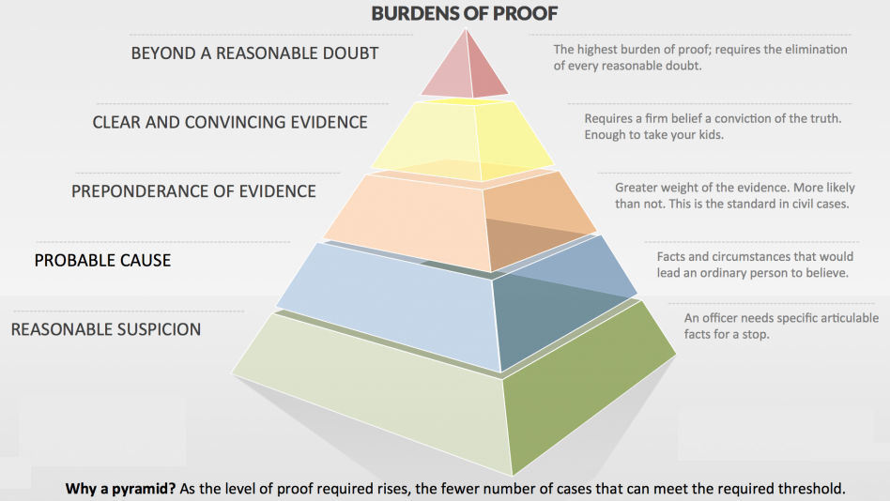
In some criminal cases, there may not be a specific victim. For example, state governments arrest and prosecute people accused of violating laws against driving while intoxicated because society regards that as a serious offense that can result in harm to others.

When a court determines that an individual committed a crime, that person will receive a sentence. The sentence may be an order to pay a monetary penalty (a fine and/or restitution to the victim), imprisonment, or supervision in the community (by a court employee called a U.S. probation officer if a federal crime), or some combination of these three things.

 | Civil Law | Criminal Law
Definition | Civil law deals with the disputes between individuals, organizations, or between the two, in which COMPENSATION is awarded to the victim.  Civil cases usually involve PRIVATE DISPUTES between persons or organizations | Criminal law (also known as ‘penal law’) is the body of statutory & common law that deals with crime & the legal punishment of CRIMINAL OFFENSES.  Criminal cases involve an action that is considered to be harmful to society as a whole as recognized by BREAKING A CERTAIN LAW.
Case is filed by… | A private party; PLAINTIFF & defendant. | Federal, state or local GOVERNMENT; PROSECUTION & defendant.
What is the ‘Nature of the Case?’ | The court must determine whether one party has CAUSED HARM to another party; cases usually deal with individual rights & duties between individuals. | The court must determine whether one party has VIOLATED A STATUTE (public law) that prohibits some type of activity; cases deal with offenses against society as a whole.
Examples | Landlord/tenant disputes; divorce proceedings; child custody proceedings; property disputes (real estate or material); a government legitimizes a potential infringement upon an individual’s civil right or liberty. | Theft (by deception or unlawful taking); aggravated assault; armed robbery; trafficking a controlled substance; alcohol intoxication; driving under the influence.
Who can Appeal? | Either party may appeal a decision in a civil law suit. | Only the DEFENDANT may appeal a court ruling in a criminal case. The prosecution cannot appeal if the defendant is found not guilty.
“Burden of Proof” | “PREPONDERANCE OF EVIDENCE” – 50.1%  Burden of proof is initially on the DEFENDANT after initial evidence & claims are made (think of a weight scale determining the outcome). | “BEYOND A REASONABLE DOUBT” – 95%  Burden of proof is ALWAYS on the state/government, or PROSECUTION (a government lawyer).
Type of Punishment | A defendant in civil litigation is never incarcerated & never executed.  Losing defendant in civil litigation only reimburses the plaintiff for losses caused by the defendant’s behavior. The purpose of the action is to compensate the plaintiff for any harm done.  Either party (plaintiff or defendant) can be found at fault, or liable. | A guilty defendant is punished by either incarceration in a jail or fine paid to the government, or, in exceptional cases, the death penalty. The purpose of the government’s action is to punish the potential offender.  Crimes are divided into two broad classes: Felonies & Misdemeanors. Defendant can be found guilty or not.

THE U.S. COURT SYSTEM
Civil vs. Criminal Law Name: _________________________________

Directions: Use the reading & information provided to answer the following questions. When you are finished, we will discuss your answers.

- In CIVIL LAW, what is a plaintiff?

- In CRIMINAL LAW, what is a prosecutor?

- In Criminal & Civil Law, what is a defendant?

- How does a civil case begin?

- Create an EXAMPLE of a civil case (one that has not already been mentioned).

- Whose responsibility is it to bring a criminal case to court? WHY do you think this is?

- In a criminal case, who may appeal the decision of the court? WHY do you think this is?

- What is the difference between preponderance of evidence & beyond reasonable doubt? EXPLAIN. * *

- What is the difference between civil & criminal law punishment?

