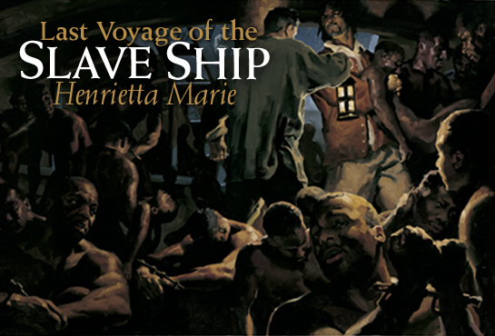
By Jennifer SteinbergPhotographs by Courtney Platt
Art by Gregory Manchess
The oldest slave ship ever excavated, wrecked off Florida in 1700, is yielding a multitude of artifacts—and blood-curdling history.
Get a taste of what awaits you in print from this compelling excerpt.
She was a British merchant ship employed in cruel commerce, her sweltering hold crammed with human chattel. It was the 18th of May, 1700, and the Henrietta Marie was nearing the coast of Jamaica, her final destination before the long ride back to England. The ship had left Africa with as many as 300 captives sold into slavery by fellow Africans—likely of rival tribes—mostly for iron and copper bars offered by the British crew. Many died along the way; slave-ship mortality averaged 20 percent.
As land appeared on the horizon, Captain Thomas Chamberlain, anxious to conduct business, ordered his crew to prepare the prisoners for arrival. Goaded onto deck, men, women, and children were fed, cleaned, shaved, and oiled, their wounds finally tended, in preparation for sale.
At Port Royal, naked and in chains, slaves went on the auction block. Potential buyers might prod their bellies, poke fingers in their mouths to check their teeth, and even taste their sweat—thought by some to be a gauge of health. By one estimate Henrietta Maries cargo grossed well over 3,000 (more than $400,000 today) for the ships investors. Most of the captives were headed for sugar plantations where theyd be worked to exhaustion, many dying within five to ten years.
Their fate was not Chamberlains concern. Captain and crew weighed anchor in late June and set a homeward course, their ship now packed with New World sugar, cotton, wood, indigo, and leftover trade goods. But storms plagued their exit and the ship foundered on New Ground Reef, 34 miles (55 kilometers) off Key West, Florida. All aboard perished at sea.
It was nearly 300 years before treasure hunters, employed by salvager Mel Fisher, raised the first relics from the wreck. But their passion was gold, and they soon abandoned the slaver to search for richer ships. In the 1980s and 90s other divers continued the salvage as scientists began conserving the rescued items. Today those scientists are in the water, examining the ships fragile hull and coaxing the last artifacts from the sand. Their work is key:Henrietta Marie is the oldest slaver ever excavated and one of only a handful from American waters. Says marine archaeologist David Moore, “Shes a vital piece of history.”

