The Legislative Branch
The Implied Powers

Name: __________________________________________ Date: _____________________

Answer the following questions using your notes, the textbook, and online resources. You will need to examine the case of McCulloch v Maryland to help you with part of this.

1. What is the constitutional basis for the implied powers?

2. What is the Necessary and Proper Clause also known as? Why?

3. Describe how the battle over the First National Bank of the United States is a battle over implied powers of the Constitution.

4. Between the strict constructionists and the liberal constructionists, which is more likely to favor implied powers?

5. How did the McCulloch v. Maryland case increase the powers of Congress?

Analyze the graph below and answer questions 6-10.
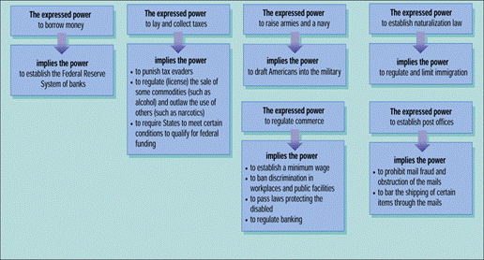

6. Why do you think there are certain implied powers listed below and in conjunction with an expressed power?

7. Look at the expressed power to lay and collect taxes. Which of the implied powers do you think seem to be strict and which do you think seem to be liberal (constructionist)?

8. What expressed power allows Congress to draft Americans into the military?

9. What expressed power allows Congress to regulate and limit immigration?

10. Choose three of the powers on the chart and explain specifically why we can assume that these powers belong to Congress.

