Name:
Native American Myth or Fact?
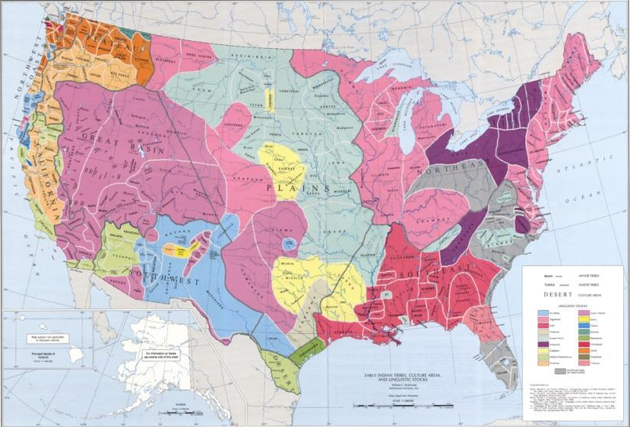
“New World” Narrative: When the early explorers landed in North America, they discovered a sparsely populated "New World."

Alternative Narrative: When Columbus landed in Hispaniola in 1492 he did not discover this land. Columbus could not discover what Native peoples already knew & owned. Rather than finding a "New World," Columbus established contact with a very old world and facilitated the meeting of two ancient cultures - European & Native American. With the arrival of the slave trade, the Spanish facilitated the meeting of three ancient cultures - African, European, & Native American

Which narrative do you think is true? Explain why

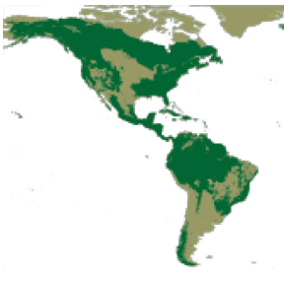
"Virgin Wilderness" Narrative: When the European settlers arrived, they found a pristine, virgin wilderness, & a people untouched by white civilization.

Alternative Narrative: When Europeans arrived, American Natives had already altered their various environments to fit their cultural needs, and their numbers had been dramatically decimated by earlier contact with European disease.

Which narrative do you think is true? Explain why

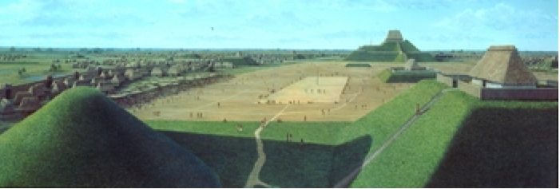
"Primitive, Uncivilized, and Heathen Savage" Narrative:
Ancient American tribes were so primitive that they never attained the agricultural or technological sophistication of other ancient peoples. Thus, when European settlers arrived in the "New World", they encountered bands of primitive, uncivilized, heathen savages.

Alternative Narrative: Many tribes had attained impressive levels of agricultural, cultural, and/or technological sophistication prior to the "discovery" of the "New World" by Europeans. When European settlers arrived there were 500-600 separate tribal societies in North America, most of which were highly civilized in terms of their political, economic, social, and spiritual development. Each society had developed the capacity for unification, had learned how to adapt to their natural environment, had achieved some sense of group identity and ethnic pride, and had created its own system of family and social organization.

Which narrative do you think is true? Explain why
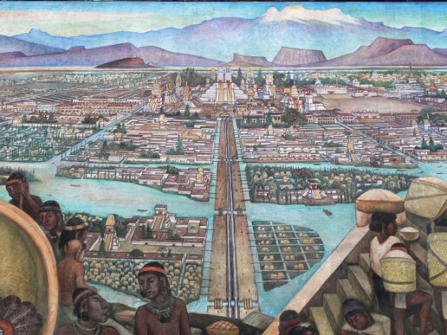
“European Superiority” Narrative: Native Americans technology was very primitive and little had been developed in architecture, farming, tools, weapons, or other technologies.

Alternative Narrative: The indigenous people were actually just as, if not more, developed than the Europeans. The only major advantage the Europeans had was iron, the civilizations in the Americas had not developed metal weapons or tools yet. Outside of that the Europeans lacked any major developments the natives didn’t at least have something comparable to.

Which narrative do you think is true? Explain why

Directions: Read the excerpt, put it in your own words, and then answer the prompt.
Excerpt from Second Treatise on Civil Government by John Locke, 1689:
“There cannot be a clearer demonstration of anything, than several nations of the Americans are of this, who are rich in land, and poor in all the comforts of life; whom nature having furnished as liberally as any other people, with the materials of plenty, i.e. a fruitful soil, apt to produce in abundance, what might serve for food, [clothing], and delight; yet for want of improving it by labor, have not one hundredth part of the conveniences we enjoy: and a king of a large and fruitful territory there, feeds, lodges, and is clad worse than a day-laborer in England.”

1) What is the overall message of the first half of the quote (before the line)? __________________________________________________________

2) What is the overall message of the second half of the quote (after the line)? _________________________________________________________

Prompt: European Governments sent teams of Exploration and Settlement to the “New World” for several different reasons. Using your knowledge from the information on Native American narratives and the John Locke excerpt above, explain whether Europeans were justified in their reasons for settling in the Americas or whether their actions were not justified. Include one example to support your argument from the readings or the excerpt.
________________________________________________________________________________________________________________________________________________________________________________________________________________________________________________________________________________________________________________________________________________________________________________________________________________________________________________________________________________________________________________________________________________________________________________

