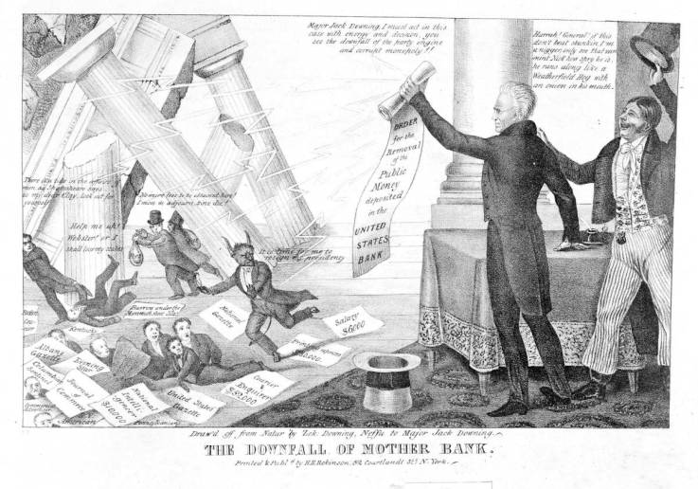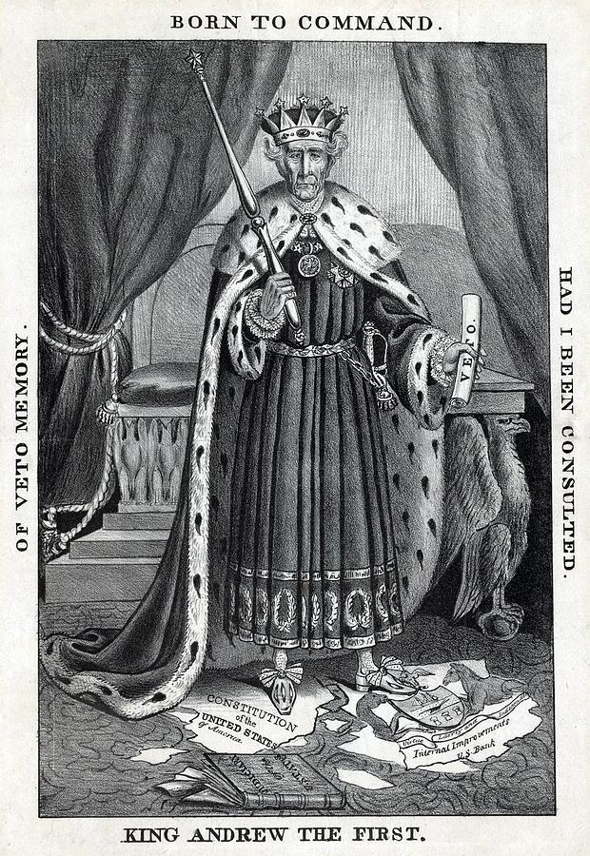

Doc. B

Paper: “Order for the removal of public money deposited in the United States Bank”